**OSU Drupal 6 Currently Installed Modules:**

* Administration menu
* Automatic nodetites
* Biblio
  + Biblio
  + Biblio - PubMed
* CAPTCHA
  + reCAPTCHA
* Content Construction Kit (CCK)
  + Content
  + Content Copy
  + Embedded Audio Field
  + Embeded Image Field
  + Embeded Media Field
  + Embeded Video Field
  + Fieldgroup
  + FileField
  + ImageField
  + ImageField Tokens
  + Link
  + Node Reference
  + Number
  + Option Widgets
  + Text
  + User Reference
* Caching
  + CacheRouter
* Core - optional
  + Aggregator
  + Book
  + Color
  + Content Translation
  + Database Logging
  + Help
  + Locale
  + Menu
  + Path
  + PHP filter
  + Poll
  + Profile
  + Taxonomy
  + Throttle
  + Trigger
  + Upload
* Core - required
  + Block
  + Filter
  + Node
  + System
  + User
* Date/Time
  + Date
  + Date API
  + Date Copy
  + Date Popup
  + Date Repeat API
  + Date Timezone
* Gallerix
* Glossary
* Image Cache
  + Image API
  + Image API GD2
  + ImageCache
  + ImageCache Actions
* OSU Drupal
  + OSU Search
  + OSU SSO
  + OSU Update
* Other
  + Advanced Help
  + Announcement
  + disable form fields
  + Glossary
  + IMCE
  + jCarousel
  + Menu Breadcrumb
  + MIME Detect
  + Nice Menus
  + Path Filter
  + Path Redirect
  + Pathauto
  + Site map
  + Token
  + Transliteration
* User Interface
  + IMCE
  + IMCE Mkdir
  + IMCE WYSIWYG API Bridge
  + jQuery UI
  + jCarousel
  + WYSIWIG
* Views
  + Views
  + Views Carousel
  + Views exporter
  + Views UI
* Webform

**Login**

<https://dashboard.pantheon.io/sites/b2d43dec-f491-4355-8c8b-639b471d51e3#dev/code>

Login: [Davidv2@hotmail.com](mailto:Davidv2@hotmail.com)

PW: 7pacific

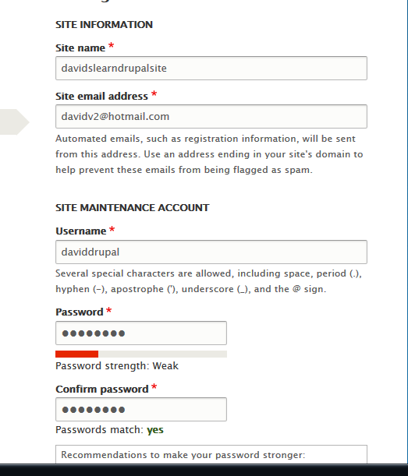

PW 7pacific

davidv2@hotmail.com